**Que 1**) Plot a histogram,

10, 13, 18, 22, 27, 32, 38, 40, 45, 51, 56, 57, 88, 90, 92, 94, 99

**Solution:**

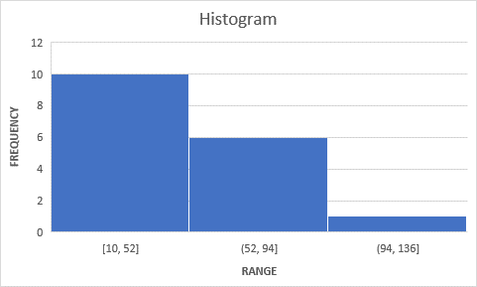

**Que 2)** In a quant test of the CAT Exam, the population standard deviation is known to be 100. A sample of 25 tests taken has a mean of 520. Construct an 80% CI about the mean.

**Solution:** Confidence Interval about mean is given by :

Value of z statistics at 80% level of significance for 2 tailed is : 0.8416

Lower limit = 520 – (0.8416)*100/5 = 503.168

Upper limit = 520 + (0.8416)*100/5 = 536.832

**Hence the 80% confidence interval about the mean is (503.168 , 536.832)**

**Que 3)** A car believes that the percentage of citizens in city ABC that owns a vehicle is 60% or less. A sales manager disagrees with this. He conducted a hypothesis testing surveying 250 residents & found that 170 residents responded yes to owning a vehicle.

1. State the null & alternate hypothesis.
2. At a 10% significance level, is there enough evidence to support the idea that vehicle owner in ABC city is 60% or less.

**Solution:**

Null hypothesis (H0): The percentage of citizens in city ABC that owns a vehicle is equal to or greater than 60%.

Alternate hypothesis (H1): The percentage of citizens in city ABC that owns a vehicle is less than 60%.

To test the hypothesis, we can perform a one-sample proportion z-test. Given that we have sample data with 170 out of 250 respondents owning a vehicle, we can calculate the sample proportion

$$Z= \frac{p-P}{√\frac{(P*(1-P)}{n}}$$

$$Z= \frac{0.68-0.60}{√\frac{(0.6*(1-0.6)}{250}}$$

**Z = 2.581**

With a significance level of 10%, the critical z-value for a one-tailed test is approximately 1.28. Since the calculated z-value (2.58) is greater than the critical value, we reject the null hypothesis. There is enough evidence to support the idea that the percentage of vehicle owners in ABC city is less than 60%.

**Que 4)** What is the value of the 99 percentile?

2,2,3,4,5,5,5,6,7,8,8,8,8,8,9,9,10,11,11,12

**Solution:**

N = 20

99*N/100 = 19.8 =20

**Value corresponding to the 20th observation is the 99 percentile = 20**

99% of the observations lie above 20

**Que 5)** In left & right-skewed data, what is the relationship between mean, median & mode?

Draw the graph to represent the same.

In left-skewed (negatively skewed) data:

- The mean is less than the median, which is less than the mode.

In right-skewed (positively skewed) data:

- The mode is less than the median, which is less than the mean.

This relationship occurs because the skewness pulls the tail of the distribution toward the direction of the skew, affecting the position of the mean, median, and mode differently.

